Role of Artificial Intelligence in Healthcare

Buzz A* Peter S
Professor Associate Professor
Dept. of Computer Technology Dept. of Information Technology,
Excel University Excel University New Delhi, INDIA New Delhi, INDIA
e-mail: buzz@exceluniversity.ac.in e-mail: peter2@exceluni.ac.in

Mcrath Willman East A P
Professor, Dept. of Computer Technology Research Scholar, Dept. of Information Tech.,
School of Engineering Excel University
ABC University, Phildelphia, USA New Delhi, INDIA
e-mail: mcrath@abcuniversity.ac.in e-mail: east@exceluniversity.ac.in

Abstract: Artificial intelligence (AI) is quickly changing how we live our lives, changing how we communicate with the outside world, how we make decisions, and how we interact with organizations. With the development in machine learning, natural language processing, and data analytics, AI is transforming the way we communicate, purchase, and consume. This study focuses on how artificial intelligence affects consumer decisions while making purchases. The study of changing consumer behavior is the main emphasis of this article, which is predicated on the idea that AI apps would use a variety of analytics techniques to gather additional information about users and their needs. The goal of this article is to look into how artificial intelligence is affecting consumer behavior by using various analytics to understand more about the needs and preferences of users. In this study, Data is collected through secondary sources like journals, publications, and other project sources. As per the study’s findings, firms can enhance their ability to target and convince customers to make purchases by leveraging the data gathered by these systems. This article also discusses the impact of artificial intelligence (AI) on consumer behavior and how it may determine future market trends.
Keywords: CART, Classification, Intrusion detection system, Machine learning algorithms, Random forest.
—————————— ——————————

INTRODUCTION

The market for custom bikes has been growing steadily in recent years as people are looking for unique and personalized vehicles. But depending on several variables, like the kind of bike, the brand, and the specs, bespoke bike costs can differ dramatically. Therefore, it is crucial to develop a system that can accurately predict the price of a custom bike. Machine learning has shown tremendous potential in predicting prices in various industries, and the custom bike market is no exception. By using machine learning algorithms, we can analyze historical data and make predictions about the price of a custom-built motorcycle. This can help potential buyers and sellers to have a better understanding of the market value of a custom bike. In this research paper, we present an innovative software solution for custom bike price prediction using machine learning techniques. Our system utilizes a comprehensive dataset of custom bike specifications and prices to train a machine learning model. Based on the features of a custom bike, the model can accurately predict its price. The paper will also discuss the methodology used in collecting and cleaning the data, feature selection, model selection, and performance evaluation. By the end of this paper, readers will have a better understanding of how machine learning can be used to predict the price of custom bikes accurately.
The software solution we have developed is user friendly and can be used by custom bike manufacturers, dealers, and enthusiasts. The system can help in making informed decisions about pricing, buying, and selling custom bikes. The accuracy of the price prediction can help in eliminating the risk of overpricing or underpricing, which can lead to financial losses. In addition, our commitment to transparency is evident through the incorporation of Explainable AI (XAI) methods in our model. This ensures that the decision making process of our custom bike price prediction model can be interpreted and understood. XAI methods provide insights into how the model arrives at its predictions, enhancing user trust and facilitating a deeper understanding of the market dynamics. The f indings of this study can assist buyers and sellers make wise decisions by offering insightful information about the custom bike industry. Furthermore, this study may be used as a guide for next studies on price prediction in the custom bike market.

LITERATURE REVIEW
The emergence of Industry 4.0 has transformed manufacturing and industrial processes, with artificial intelligence (AI) and machine learning (ML) playing pivotal roles. This literature review aims to synthesize existing research on the impact of AI, ML and IoT within Industry 4.0, drawing insights from previous studies and identifying key trends and gaps in current knowledge. Foundations of Industry 4.0:Previous research by Lu et al. (2017) laid the groundwork for understanding the core concepts of Industry 4.0, including cyber-physical systems and the Internet of Things (IoT) [14]. Their study emphasized the importance of digital technologies in enabling intelligent manufacturing ecosystems. Building upon this foundation, Schumacher et al. (2018) explored the integration of AI and ML techniques within Industry 4.0, highlighting their potential to drive efficiency, innovation, and competitiveness [15]. Applications of AI and ML in Manufacturing: Research by Tran et al. (2019) investigated the application of AI and ML in predictive maintenance for manufacturing equipment [16]. Their findings demonstrated significant improvements in equipment uptime and maintenance efficiency, illustrating the tangible benefits of AI-driven predictive analytics. Additionally, Wang et al. (2019) examined the role of AI-enabled robotics in automating production processes, showcasing how intelligent automation enhances productivity and flexibility in manufacturing operations [17]. AI and ML in Supply Chain Management:Studies by Jiang et al. (2018) and Sun et al. (2020) explored the application of AI and ML algorithms in supply chain management within the context of Industry 4.0. Jiang et al. (2018) investigated the use of predictive analytics for demand forecasting, highlighting the role of AI in improving supply chain visibility and responsiveness.
Sun et al. (2020) focused on AI-driven optimization techniques for inventory management, demonstrating how ML algorithms minimize stock outs and excess inventory while improving cost efficiency [18, 19]. Challenges and Ethical Considerations: Research by Mittal et al. (2019) examined the challenges and ethical considerations associated with the widespread adoption of AI and ML in Industry 4.0 [20]. Their Gupta, et al and the implementation of a Choice-Based Credit System (CBCS) in engineering education. This allows students to select courses based on their interests, aspirations, and career goals, enabling personalized learning experiences and fostering a culture of lifelong learning. study identified issues

such as data privacy, algorithmic bias, and job displacement as significant concerns that require careful consideration. Additionally, Liu et al. (2021) emphasized the importance of robust cyber security measures to mitigate the risks of cyber threats and ensure the integrity of AI-driven industrial systems [21].
METHODOLOGY

The overall design consists of a microcontroller, microprocessor, motor drivers, motors, Lidar sensor, tracking camera, display, and battery, as shown in Fig. 1. The battery provides the required input power to the robot and its controlling peripherals. The Lidar sensor provides a 2D 360° map data to the microprocessor. The tracking camera gives the odometry data with respect to the surroundings to the microprocessor. This data given by the Lidar sensor and tracking camera is processed by the microprocessor with the help of Simultaneous Localization and Mapping (SLAM) algorithms of ROS. The microprocessor processes the data and converts it into the human unreadable format and also some controlling data used to control the actuators via the microcontroller, which will do cleaning actions. The controlling data, such as directional velocities and other important data, is given to the microcontroller by the microprocessor. The motors are driven with the help of motor drivers, which are controlled by the microcontroller through the PWM technique.
Specifications
The Autonomous Floor Cleaning Robot is a three- wheeled omni drive where each wheel is driven by a DC motor. These motors are controlled by motor drivers through a central control unit which is the microcontroller. Traction wheels provide better friction resulting in rich maneuverability of the robot. The robot gets real-time feedback from the surrounding environment through a tracking camera and Lidar sensors. These sensors are combined with a microprocessor, which analyses the sensor data received and transmits it to the microcontroller, which then sends the signal to the actuators to carry out the appropriate tasks.
PROPOSED FRAMEWORK
This section presents the proposed framework for integrating AI and blockchain to enhance privacy for cloud databases. System Architecture the decentralized architecture comprising of blockchain network and distributed cloud databases is shown in Figure 1.

RESULTS AND DISCUSSION

Generative simulated intelligence is ready to alter medication during the next few years. A speedy PubMed question utilizing the term ‘ChatGPT’ recovered 924 distribution records starting around 31thIJuly 2023 (4 records inI2022 andI920 records in the initial seven months of 2023, similar question recovered 1049 records when rehashed 18 days after the fact, 18 August 2023). While ChatGPT has almost certainly overwhelmed the generative man-made intelligence scene in 2023, it tough to be noticed that it is nevertheless one illustration of the GPT design and models. We anticipate that generative simulated intelligence should keep moving during the next few long stretches of time. The accompanying conversation will address a few normal worries, difficulties and general open doors related with generative simulated intelligence and related items like ChatGPT. The question arise that if it is possible to relay on Generative AI and if it is safe and Reliable in clinically process?
Table. 1. DFIG wind turbine parameters
Symbol | Value | Description
P | 4 | Number of poles
J | 1000(kg.m²) | total inertia
fr | 0.0024(Hertez) | equivalent friction coefficient of the tree
R | 35.255 (m) | the turbine radius
Rr  Rs | 0.021(Ω)  0.012(Ω) | Rotor winding Resistance  Stator winding Resistance
Ls | 0.0137 (H) | Stator Inductance
Lr | 0.0136 (H) | Rotor Inductance
M | 0.0135 (H) | Mutual inductance
g | 0.03 | glissement

Trust and approval are basic to the effective arrangement of generative man-made intelligence in medication and medical services. ChatGPT’s reactions have uncovered a wide and, all the more fundamentally, capricious scope of value and veracity. This ‘unusualness’ is the primary boundary to reception achievement, since we don’t have any idea when it will return a clever response and when its responses will be off-base or misdirecting, or at the end of the day, when too trust generative simulated intelligence and when not to trust it, particularly when the client isn’t adequately able to evaluate the quality (exactness and culmination) of a given reaction [6].This idea of trust raises comparable issues like clinical wellbeing and unwavering quality. Until we have an appropriately restoratively prepared and approved generative computer based intelligence (ChatGPT, for instance, isn’t particularly medicinally prepared), there will constantly be interconnected issues of trust, security, and dependability that forestall any huge clinical use of it. We characterize “therapeutically prepared” as a model that has been explicitly and broadly prepared using a corpus of value proof based clinical writing that properly cover a specific clinical area of specialization.

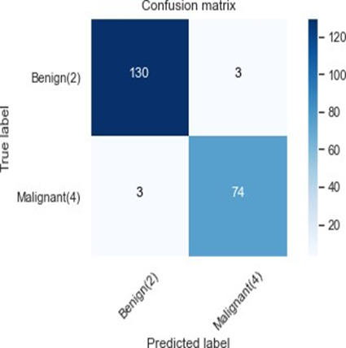

Fig. 1 Caption

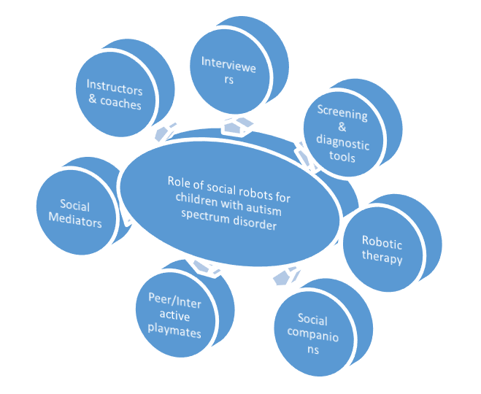

Fig. 2 Caption

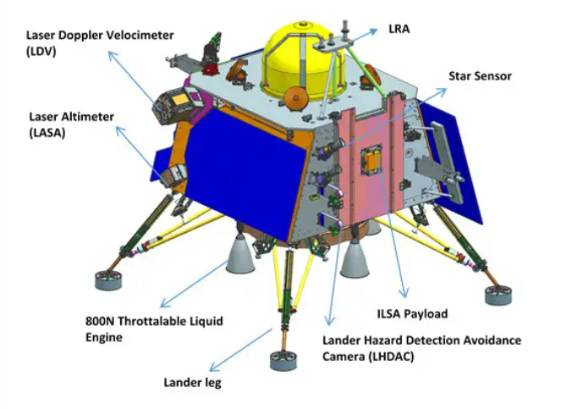

Fig. 3 Caption

5. CONCLUSION

In conclusion, this paper focused on addressing the critical issue of intrusion detection in IoT networks, recognizing the vulnerability of such networks to various security threats. Through the utilization of machine learning techniques, specifically the RandomForest Classifier, we aimed to enhance the accuracy and effectiveness of intrusion attack prediction in IoT environments. The research began with a thorough exploration of the challenges posed by imbalanced datasets and the inherent vulnerabilities of IoT networks to security threats. Leveraging the IoT_Modbus dataset from ToN-IoT datasets, which provided real-world network traffic data, we proceeded with preprocessing steps aimed at mitigating dataset imbalances. By employing oversampling techniques, we balanced the dataset to improve the performance of the machine learning model. Subsequently, the RandomForest Classifier was applied to the preprocessed dataset, taking advantage of its ensemble learning capabilities and robustness in handling complex datasets. The classifier was trained and evaluated using a combination of training and validation sets, with a focus on achieving accurate intrusion attack predictions. Throughout the experimentation phase, the RandomForest Classifier demonstrated promising results, showcasing its efficacy in accurately classifying instances of normal network activity and various intrusion attacks. The use of XAI techniques provided useful insights into effect of each feature from dataset on predicting anomaly category.

ACKNOWLEDGEMENT

The authors are very much thankful to management for providing us facilities to conduct the experiments in the institution’s laboratory and colleagues for their support to prepare this paper. We are also thankful to the Science & Technology department for approving our research proposal and providing us grants to conduct research activities.

References
[1] Jocky R Mic, Craze P Smith, Stephen K. Dam (2021), “Comparative Study of Prefabrication and Conventional Construction Methods: Case Study of Residential Complex” International Jour. of Green Technologies, Vol. 27, No.03, Pp 156-165.
[2] Buzz A, East A P, Times Y R (2024) “Applications of Recycled Aggregate Material in Road Construction” American Journal of Civil Engineering 47(2): 35-42.
[3] T. N. Boob and Y. R. M. Rao (2012) “Critical Evaluation of Urban Open Spaces in Development Plan - A Case Study Recent Trends in Civil Engineering & Technology”, Int. Jour. of Urban Development”, Vol. 02, No.:02, Pp.09-26
[4] APHA, Standard Methods for the Examination of water and wastewater, 21st Edn. U.S.A. 2005
[5] Jocky R Mic, Craze P Smith, Stephen K. Dam “Studies on Recycling of Treated Waste from CETP for Green Belt Development” at International Conference on “Special conference on water quality” organized by the Central Pollution Control Board, New Delhi, during 14-15 July2023.

[6] Y. M. Bajaj and P. K. Gupta, A Text Book on Machine Leaning, Indian Society for Technical Education, New Delhi, 2023.
[7] Krishnan K. Srikanth, Applications of Recycled Aggregate Material in Road Construction, ABC University, 2020

